MSXPi Quick Start Guide
Version 1.6
Real hardware (MSXPi interface + Raspberry Pi) and openMSX. Everything else is in the Users and Developers Guide.
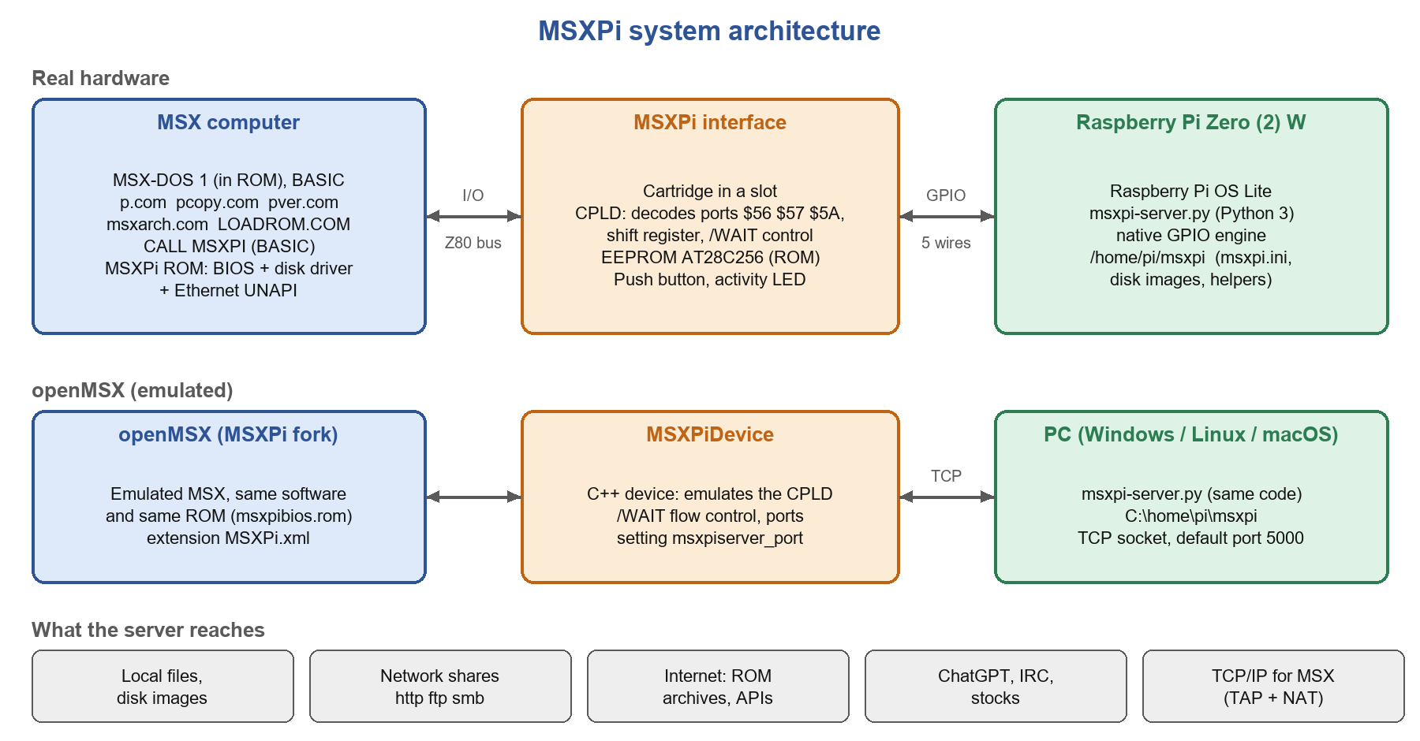
Figure 1: What you are setting up
Read this first: Version 1.6 breaks compatibility with earlier ROMs and servers. Upgrade the ROM, the msxpi-server, the client commands (.COM files) and, on real hardware, the CPLD firmware together. A v1.6 ROM on older CPLD firmware still works, only slower.
Pick your path: Part 1 for a real MSX with an MSXPi interface, Part 2 for openMSX with no hardware. Each step ends with a check - do not go on until the check passes.
Commands typed on the MSX are shown as C:\> lines or in a grey box; the same commands work on hardware and in openMSX.

Part 1 - Real hardware

What you need
- The MSXPi interface with an AT28C256 EEPROM. Build notes: documents/MSXPi Assembly Instructions.txt.
- A Raspberry Pi Zero W or Zero 2 W (a Pico does not work) with its 40-pin header on the side that matches your PCB, and a micro SD card of 8 GB or more.
- An MSX with a disk or SD interface (MSX-DOS 1, MSX-DOS 2 or Nextor) and a way to copy files to it from a PC. MSXPi's own ROM contains MSX-DOS 1 only: Nextor or MSX-DOS 2 must come from that other disk interface, which MSXPi coexists with - the best setup.
- Only if the CPLD is not programmed yet: an Altera USB-Blaster and Quartus 13.0 SP1 on Windows.
- The files in this repository: software/target (programs and ROM), hardware/CPLD_Project (firmware).

Step 1 - Program the CPLD (only if new or older than v1.6)
- Plug the interface into the MSX, connect the USB-Blaster to the JTAG connector, switch the MSX on.
- In Quartus: Tools, Programmer, mode JTAG, Add File, choose the .pof for your board, tick Program/Configure and Verify, Start.
Board | File in hardware/CPLD_Project
V1.3 Rev.1 (built for v1.3 to v1.5) | MSXPi_v1.6.pof
V1.1 Rev.1, V1.2.1b | v1.1/MSXPi_v1.6_wait.pof
v0.8.2 / v1.0 (PCB v0.7 Rev.7) | v0.8.2/MSXPi_v1.6_polled.pof

Check: in BASIC, PRINT INP(&H57) must not print 254 or 255 (no CPLD answered); pver shows the same build ID in readable form later. Older boards need extra settings later (see the Legacy Support document).

Step 2 - Write the ROM to the EEPROM
- Copy at28c256.com and msxpibios.rom from software/target to an MSX disk. The interface must be plugged in; the Pi is not needed yet.
- If the interface already boots a ROM, remove its enable jumper (SLTSL) first.
- Boot MSX-DOS and list the slots: at28c256 /i. Write down the slot of the interface.
- Write the ROM (slot 2 in this example): at28c256 /s 2 msxpibios.rom. Add /r to write slowly if your chip fails. The chip is write-protected afterwards.
- Power off and set the jumpers. With another disk interface (recommended): remove SLTSL. To boot MSX-DOS 1 from a disk image on the Pi: close SLTSL and select the bank with the MSXPi ROM.
Check: with the enable jumper closed, CALL MSXPIVER in BASIC prints the version.

Step 3 - Prepare the Raspberry Pi
Write "Raspberry Pi OS Lite (32-bit)" with Raspberry Pi Imager (user pi, SSH on, your WiFi entered), boot the Pi, log in and run:
wget https://tinyurl.com/MSXPi-Setup
chmod 755 MSXPi-Setup
bash ./MSXPi-Setup

The script checks the Pi, the network and the clock, installs Python 3 with the modules requests, fs and RPi.GPIO (fs needs pkg_resources, so it also pins setuptools below version 81), the packages for archives, audio and networking, builds the native GPIO engine, creates the MSXPi home directory /home/pi/msxpi (server, msxpi.ini, disk images, helpers), starts the server, checks that it runs, and reboots - a few minutes, not the hour earlier versions could take.
It asks which board you have; skip the question with --board v1.3, --board v1.1 or --board old, and see --help for the rest (WiFi, --no-reboot, ...). It is safe to run again later: it updates the server and repairs what is missing, and never overwrites your msxpi.ini.
In msxpi.ini a board without the shutdown push-button needs var RPI_SHUTDOWN=none. Optional keys: OPENAIKEY (ChatGPT), and the stock quote keys.
Insert the card, plug the Pi into the interface component side facing you, switch the MSX on. The interface LED lights when the server runs.

Step 4 - Copy the programs to the MSX
Copy everything in software/target (at least p.com, pcopy.com, pver.com, msxarch.com, msxarch.ini, LOADROM.COM, INL.CFG) to your MSX disk or SD card.
pver

Check: pver prints the board, the CPLD build, /WAIT: yes (burst) and the server version. "Connection error"? The Pi may still be booting (first boot: up to three minutes), or the versions do not match. Press ESC, wait five seconds, try again.

Step 5 - WiFi and network
p set WIFISSID Your Wifi Name
p set WIFIPWD YourWifiPassword
p wifi set
p reboot

Then, for TCP/IP programs (the Ethernet UNAPI is in the ROM; do not run RAMHELPR):
MSR I (MSX-DOS 1 only)
INL I
HOST GOOGLE.COM

Check: HOST prints an address. If not: p netreset. "DNS not found" means the resolver: use INL IP P <address>.

Step 6 - Have fun
p dir /home/pi/msxpi
pcopy m:pver.com
msxarch
p chatgpt Tell me a fun fact about MSX

Update later with msxpiupd.bat (MSX files), the setup script (server) and at28c256 (ROM). Run `p shut` before switching the MSX off.

Part 2 - openMSX

Windows: install in one step
Download software/Server/Setup/msxpi-openmsx-install.bat from https://github.com/costarc/MSXPi and double-click it. It needs no administrator rights and downloads everything it installs:
- Python 3 and the packages the server uses, 7-Zip, Stockfish and mpv (with winget).
- C:\home\pi\msxpi - the server, msxpi.ini and the disks folder.
- C:\home\pi\msxpi\openMSX - openMSX with the MSXPi device, the MSXPi.xml extension and msxpibios.rom.
- start-openmsx.bat and an MSXPi desktop shortcut.
Double-click the MSXPi shortcut. It starts the server in its own window, then openMSX as a Panasonic FS-A1WSX with the MSXPi and 4 MB RAM extensions. The MSX boots MSX-DOS from the MSXPi boot disk - no floppy image is needed. Go on with the check in step 4.
Machine ROMs: openMSX ships only the free C-BIOS ROMs; put the FS-A1WSX system ROMs in Documents\openMSX\share\systemroms. Internet on the MSX: run msxpi-openmsx-install.bat -Network (asks for administrator rights once) - see step 5. Updating: run the installer again; it keeps msxpi.ini and the disk images.

Manual install - what you need
- openMSX with the MSXPi device. The official openMSX is https://github.com/openMSX/openMSX; the MSXPi device is in the fork - download the newest release for your system from https://github.com/costarc/openMSX/releases (read its release notes).
- Python 3.9 or newer, with python -m pip install requests (pchess also needs certifi and chess; renderpage needs Pillow and playwright).
- 7-Zip on the PATH (zip, lzh, pma, 7z archives).
- The MSXPi home directory: /home/pi/msxpi (on Windows C:\home\pi\msxpi).
- The files from this repository: the server in software/Server/Python/src, the programs in software/target.

Step 1 - Create the home directory
Put in it: msxpi-server.py, mapper_detect.py and every msxpi_*.py module from software/Server/Python/src, msxpi.ini (copy msxpi-JumperLeft.ini and rename it) and a disks folder with msxpiboot.dsk and tools.dsk. On Windows create C:\home\pi\msxpi and start the server from drive C: - the server path resolves on the current drive (or set MSXPI_HOME to another folder).

Step 2 - Start the server
cd C:\home\pi\msxpi
python msxpi-server.py

It listens on TCP port 5000 and prints every command it receives. Leave it running.

Step 3 - Prepare a disk folder
Make a folder FloppyA. Copy MSXDOS.SYS and COMMAND.COM (from software/target/disks) and all the MSXPi programs from software/target into it.

Step 4 - Start openMSX
openmsx -machine Panasonic_FS-A1WSX -ext MSXPi -diska FloppyA

Check: at the DOS prompt type pver. It should show /WAIT: yes (burst) and the server version. "Connection error": the server is not running, the ports differ, or the versions do not match.
Optional - another TCP port: in the openMSX console (F10) type set msxpiserver_port 5001 and start the server with the environment variable MSXPI_PORT=5001 to match. Default: 5000.

Step 5 - Network in the emulator (optional)
With the Windows installer: run it with -Network. It installs the TAP driver, and the MSXPi shortcut sets up the network whenever it is missing (asking for administrator rights). Then on the MSX INL I and HOST GOOGLE.COM.
By hand on Windows: install the OpenVPN TAP driver, run powershell -ExecutionPolicy Bypass -File msxpi-tcpip-setup.ps1 as Administrator (again after every reboot), start the server, then on the MSX MSR I (MSX-DOS 1 only), INL I, HOST GOOGLE.COM. If the server prints "falling back to MockLink", something else has the adapter open.

Cheat sheet
Command | Does
pver | Board, CPLD, /WAIT and server version
p dir [path] | List Pi, network or r1: r2: m: locations
p cd [path] | Set / show the current path
pcopy src [dest] | Copy Pi/network to MSX (/z unpacks); pcopy a:f /path copies to the Pi
p run cmd | Run a command on the Pi (:: for a pipe)
p set NAME value | Change msxpi.ini variables (WIFISSID, OPENAIKEY, ...)
p wifi [set], p wlanreset, p netreset | WiFi, WiFi reset, rebuild the network for the MSX
p date | Set the MSX clock from the Pi
p reboot / shut / restart | Reboot the Pi / shut it down / restart the server
msxarch | Browse ROM repositories and start a game
LOADROM name /N | Load a ROM from the network
p chatgpt text | Ask ChatGPT (needs OPENAIKEY)
ESC | Abort; wait 5 seconds before the next command

When something goes wrong
Symptom | Try
"Connection error" from pver or p | Pi still booting (wait 3 min on the first boot); ESC, wait 5 s, retry; run the server by hand and read its messages; check that ROM, server and .COM files are all v1.6
pver: Board: no MSXPi found | CPLD not programmed, or the interface is not seated; check PRINT INP(&H57)
pver: /WAIT: no (polled) | Older CPLD firmware or a board without /WAIT: works, but slower
Pi reboots by itself (older boards) | Add var RPI_SHUTDOWN=none to msxpi.ini
INL: No mapper support routines found | RAMHELPR was run before MSR: cold boot, then MSR and INL only
HOST: DNS not found | INL IP P <resolver address>; run p netreset
MSX-DOS 1 does not boot from the Pi | Wait for the Pi to boot; ESC to skip to BASIC; replace msxpiboot.dsk
openMSX: nothing happens | Start msxpi-server.py first; port must match msxpiserver_port; use the fork build of openMSX

More: README.md in the repository, the MSXPi Users and Developers Guide, documents/Legacy Support.odt for older boards, and the Hard Way Raspberry Pi tutorial (English and Portuguese). Issues: https://github.com/costarc/MSXPi/issues

